🔹 What is Streamlit?
Streamlit is a free, open-source Python framework used to build interactive, data-driven web apps quickly and easily — with no front-end experience required.
You don’t need to be a web developer. If you know Python, you can build useful, beautiful data apps that run in a web browser.

✅ Key Features:
- Streamlit = Python + Simplicity + Web App
- Great for prototyping ideas, sharing AI tools, or building business dashboards
- No web dev skills needed
- Free and open source
- Free and open source
- Works great with Snowflake, Pandas, and AI tools
- Turn Python scripts into shareable web apps in minutes
- Native support for Pandas, NumPy, Matplotlib, Plotly, and more
- Real-time interactivity using widgets like sliders, dropdowns, buttons, etc.
- Ideal for data scientists and analysts who want to visualize and share insights fast

🧠 Why Use Streamlit?
Traditionally, if someone wanted to build a web app, they needed to learn:
- Frontend tools like HTML, CSS, JavaScript
- Web frameworks like Flask or Django
- Hosting and deployment
Streamlit removes all that complexity. You write a Python script, add a few special st. commands (like st.write, st.button, st.slider), and Streamlit handles everything else — including the UI.

🛠️ What Can You Do With Streamlit?
Here are some things you can build with Streamlit:
Use Case | Description
Data Dashboards | Display charts, tables, KPIs, and metrics for business data
AI/ML Model Demos | Allow users to upload data, get predictions, or view model outputs
Customer Feedback Apps | Analyze and summarize survey or transcript data
Business Tools | Build interactive tools (like pricing calculators or cost estimators)
Chatbots & NLP Tools | Interface with GPT, LLMs, or sentiment analysis tools

🖥️ Who Can Use Streamlit?
- ✅ Data analysts and scientists — to make models useful for others
- ✅ Business users — to get insights without coding
- ✅ Teachers/trainers — to create interactive tutorials or demos
- ✅ Anyone who knows a bit of Python and wants to make something people can use

🎯 Key Features of Streamlit
Feature | What it Does
st.write() | Display text, data, charts, and more
st.button(), st.slider(), st.text_input() | Interactive controls
st.file_uploader() | Allow users to upload Excel, CSV, or image files
st.dataframe() | Show tables and dataframes nicely
st.line_chart(), st.bar_chart() | Plot charts instantly
Live reload | Your app refreshes every time you save the Python file
Simple deployment | Easily deploy to the cloud (Streamlit Cloud or Snowflake)

🧩 How Streamlit Works – A Simple Flow
- You write a Python script (app.py)
- You use Streamlit commands (st.write(), st.button(), etc.)
- Run the script with: streamlit run app.py
- It opens a web page where your app is running live.
- Users can interact with it, just like any normal website!
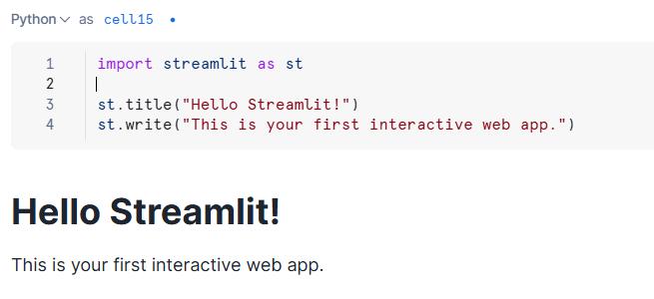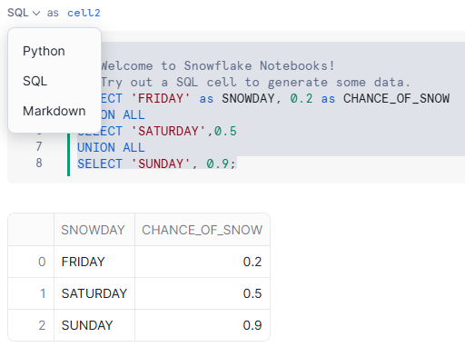


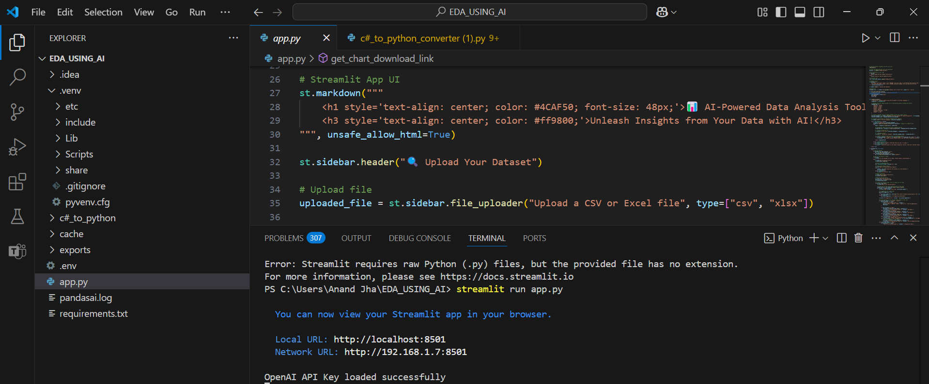
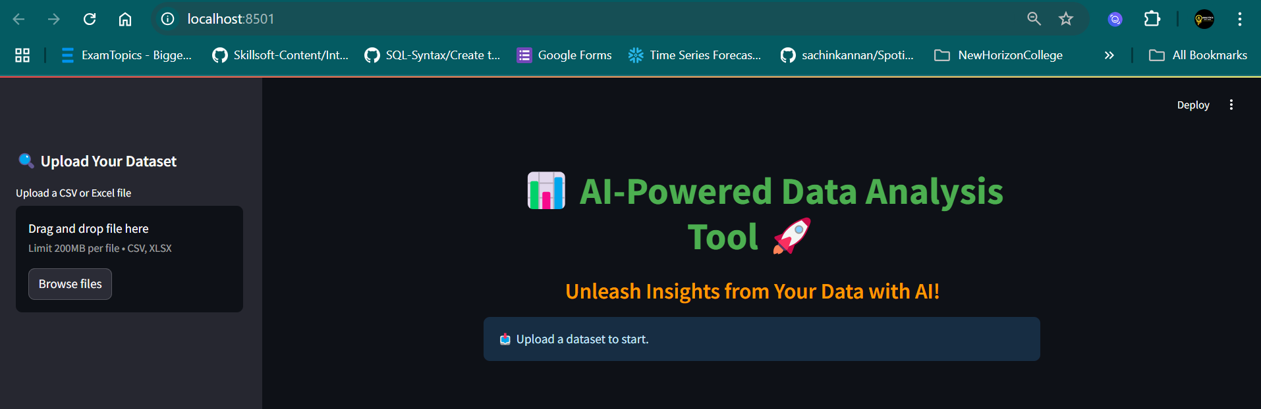

🔹 Business Problem: Call Center Sentiment Analyzer
🎯 Use Case Overview:
A company has thousands of call center transcripts stored in Snowflake. They want to:
- Analyze customer sentiment from these transcripts
- Summarize each call using an LLM
- Display insights in an interactive Streamlit dashboard
🧩 Business Goal:
Help the customer support team understand customer issues better and identify areas for improvement based on conversation analytics

🔹 Step-by-Step Plan to Build the App
1. Snowflake Setup (assumed pre-known):
- Table: CALL_TRANSCRIPTS
CREATE TABLE CALL_TRANSCRIPTS (
CALL_ID STRING,
AGENT_NAME STRING,
CUSTOMER_NAME STRING,
CALL_DATE DATE,
TRANSCRIPT TEXT
);
- Load the datasets :
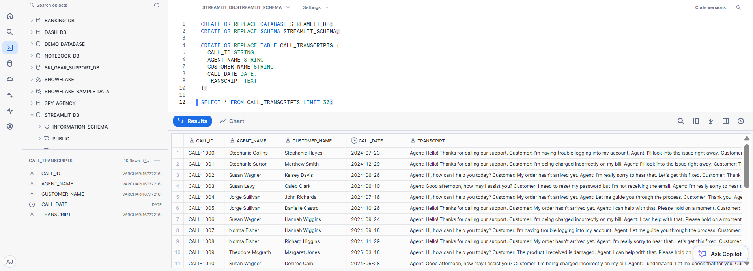
2. Streamlit App Plan:
🧱 Key Features:
- Dropdown to select an agent or date range
- Display filtered transcripts
- Button to analyze sentiment + summarize using Snowflake Cortex or OpenAI
- Show sentiment and summary for each call (AI using Cortex or external API)

📘 Understanding Snowflake Cortex AI – A Beginner-Friendly Guide
🧠 What is Snowflake Cortex?
Snowflake Cortex is an AI and machine learning service built directly into the Snowflake Data Cloud.
It allows you to perform powerful AI tasks — like summarizing text, understanding customer sentiment, or classifying messages — without needing to train a machine learning model yourself.
You just send it your data, and it returns the insights. It's as simple as writing a query or calling a function.
🔍 AI Functions We Used (with Simple Explanations)
In our Streamlit app, we used several AI-powered functions provided by Snowflake Cortex. Let's break down each one:
1️.SNOWFLAKE.CORTEX.SUMMARIZE()
🗂 What it does:
- Summarizes a long block of text into a short, clear summary.
- For example, you can take a customer support call transcript and get a 2-3 sentence summary of what happened.
💡 Why it’s useful:
- Helps managers and support teams quickly understand the key points of a long conversation without reading everything.
📌 Example:
SELECT SNOWFLAKE.CORTEX.SUMMARIZE('Customer called to report login issues...') AS summary;
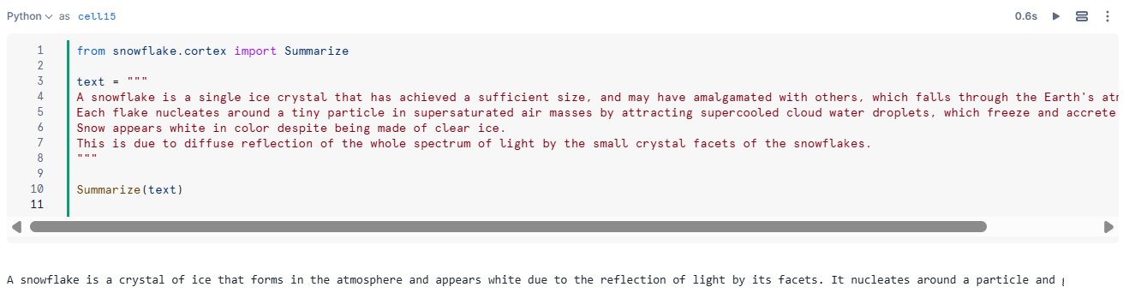

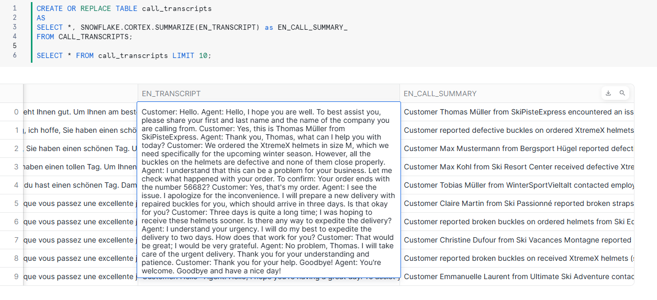

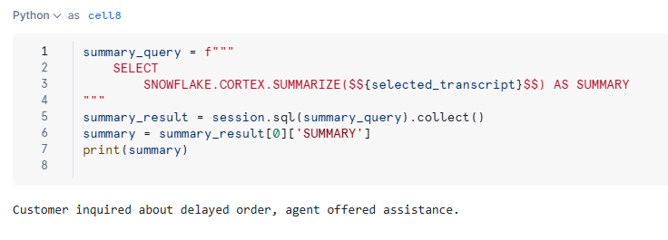
2️. SNOWFLAKE.CORTEX.SENTIMENT()
🧭 What it does:
- Detects the tone or emotion in a block of text — is it positive, negative, or neutral?
💡 Why it’s useful:
- Quickly understand how a customer feels in a support chat or survey feedback.
- Identify angry customers or happy ones automatically.
📌 Example:
SELECT SNOWFLAKE.CORTEX.SENTIMENT('I am very disappointed with your service') AS sentiment;
Output: "NEGATIVE"
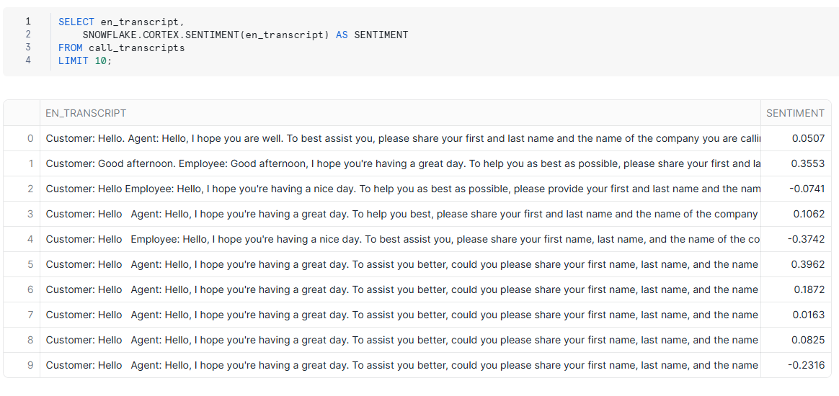
3️. SNOWFLAKE.CORTEX.CLASSIFY_TEXT()
🗃 What it does:
- Categorizes text into predefined groups or labels.
- For example, classify incoming messages as "Billing", "Technical Support", or "Account Access".
💡 Why it’s useful:
- Automates customer routing in support centers
- Helps in tagging content and understanding topics at scale
📌 Example:
SELECT SNOWFLAKE.CORTEX.CLASSIFY_TEXT( 'I forgot my password and can’t log in.',
ARRAY_CONSTRUCT('Billing', 'Technical Support', 'Account Access')) AS category;
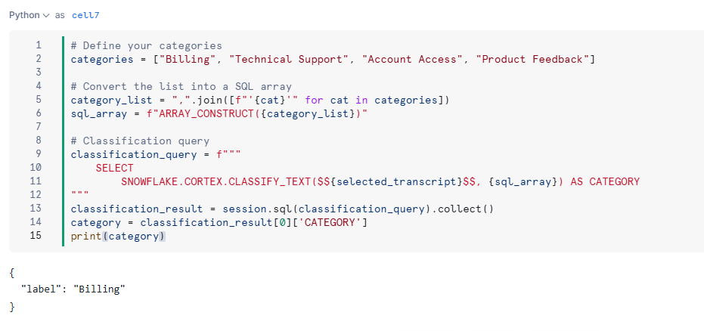
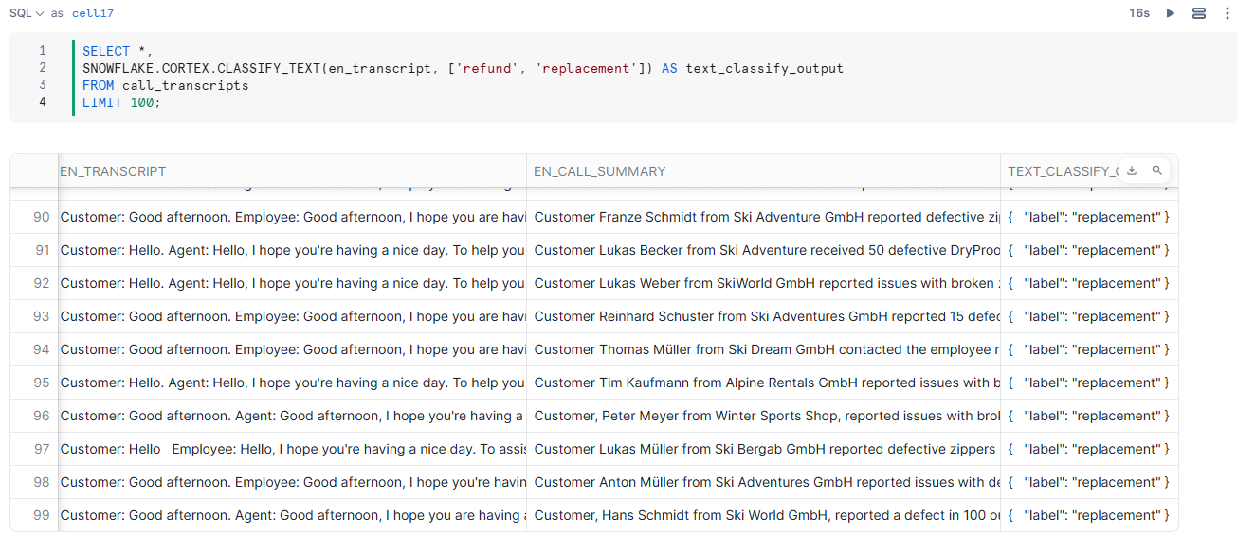
4️.SNOWFLAKE.CORTEX.TRANSLATE()
🌍 What it does:
- Automatically translates text from one language to another using AI.
💡 Why it’s useful:
- Lets companies handle customer messages in different languages and convert them into one standard language (e.g., English) for easier processing.
🌐 Supported Languages
Snowflake Cortex supports many major global languages, including:
English ('en'), French ('fr'), Spanish ('es'), German ('de'), Hindi ('hi'), Chinese ('zh'), Japanese ('ja'), Portuguese ('pt') and more...

📌 Example:
SELECT SNOWFLAKE.CORTEX.TRANSLATE( 'Je ne peux pas accéder à mon compte.','en') AS translated_text;
Output: "I can't access my account."
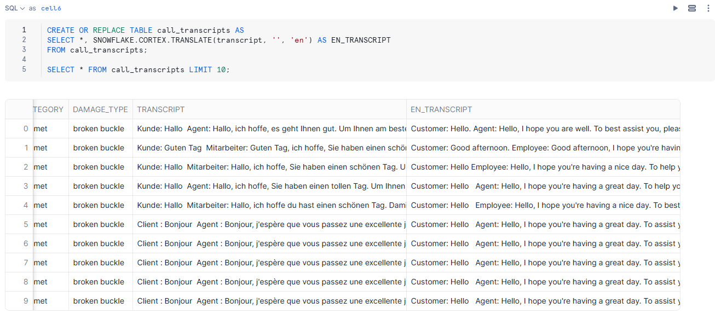
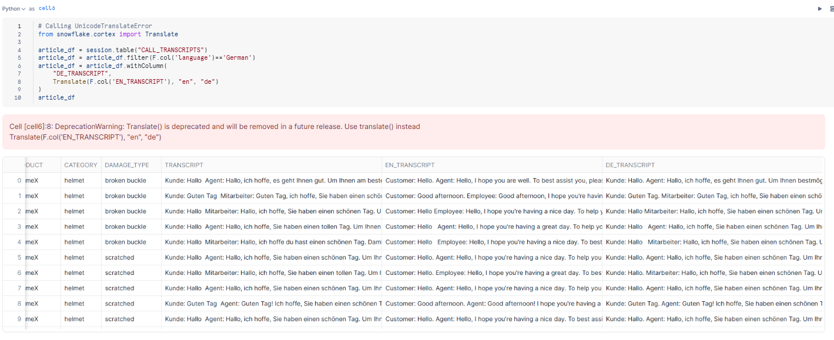
✅ How Did We Use These in Our App?
In our Streamlit app, we:
- Let the user choose a customer call transcript.
- Used SUMMARIZE() to create a short summary of the call.
- Used SENTIMENT() to analyze the mood of the conversation.
- Used CLASSIFY_TEXT() to categorize what the call was about.
- Used TRANSLATE() to convert from one language to another.
- Displayed all results instantly in a friendly web app!

🎯 Benefits for Business Users
Feature | Benefit
No need to train a model | Prebuilt AI functions are ready to use instantly
Scalable | Can analyze thousands of records at once
Accurate | Uses powerful models behind the scenes
Secure | Runs inside your Snowflake account – no data leaves your system
Fast to implement | You can build apps or dashboards in hours, not weeks

